Complaint Policy

Ralph J. Bunche Middle School

Atlanta, Georgia

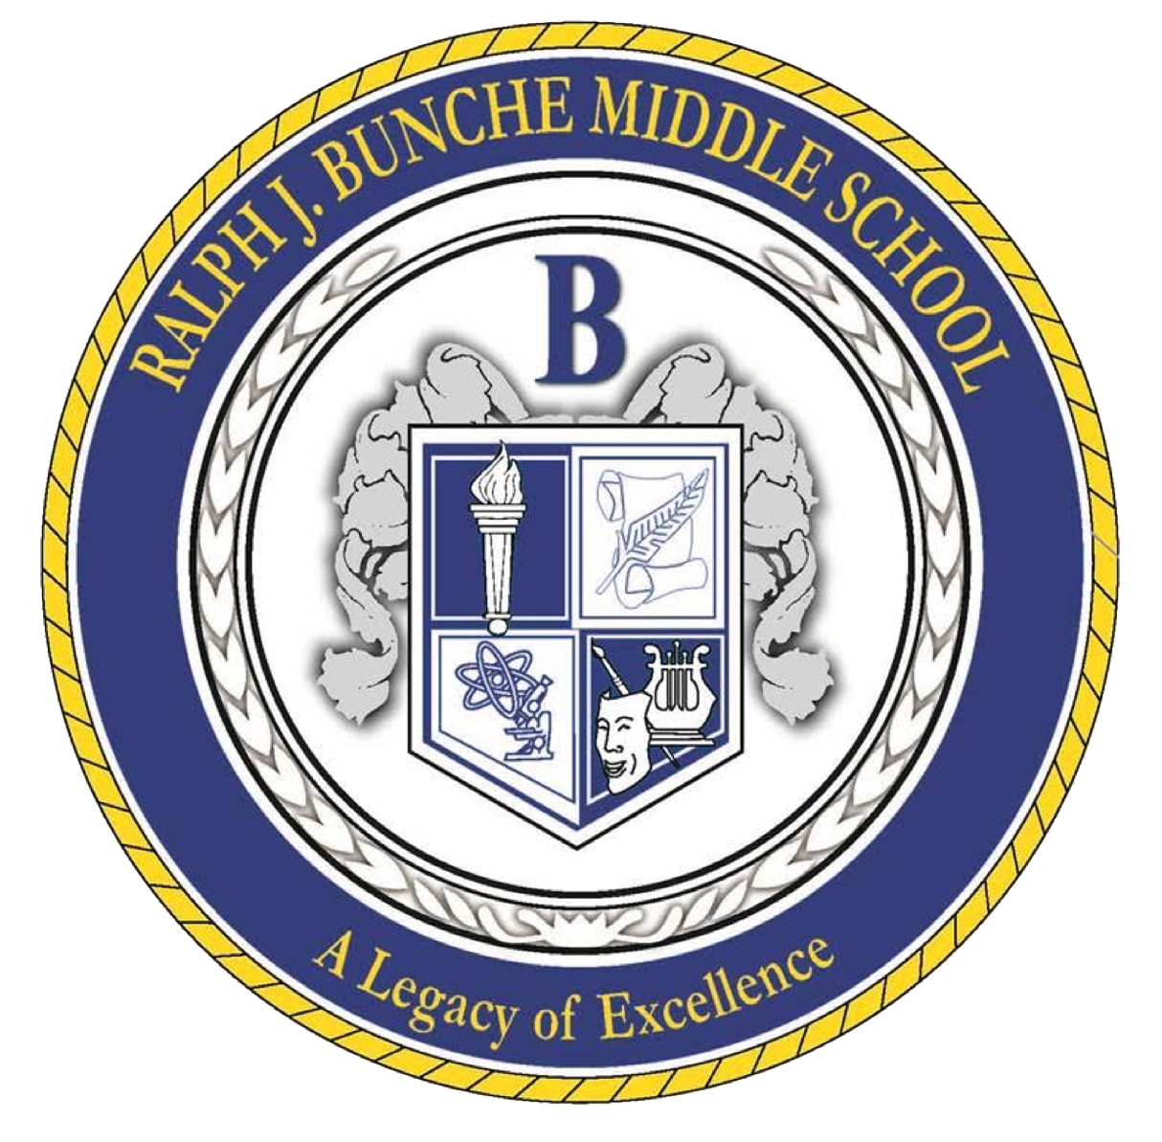

**The Bunche Mission Statement**

Through rigorous learning experiences and a challenging international education program, Ralph J. Bunche will develop 21st-century lifelong learners who are competent, caring, and contributing members of a global society and prepared for high school and beyond.

**Purpose**

At Ralph J. Bunche Middle School, we prioritize our parents' and students' feedback and concerns. We understand that conflicts and issues may occasionally arise, and we are dedicated to providing a comprehensive complaint procedure to address any grievances fairly and promptly. This procedure outlines the steps that need to be followed when making a complaint:

**Process**

We have established a formal procedure to address complaints raised by parents, legal guardians, and students. This procedure ensures that complaints are acknowledged, thoroughly investigated, and resolved to the best of our abilities. The following outlines the step-by-step process for lodging and resolving complaints as outlined in our student handbook.

**Step 1: Informal Resolution**We encourage parents or legal guardians and students to attempt to resolve complaints through informal means initially. This stage involves the following steps:

1.1. Discussion with the Teacher/Staff Member:

Parents, legal guardians, and students should approach the relevant teacher or staff member to discuss their concerns. This can be done through face-to-face meetings, phone calls, or emails.

1.2. Dialogue with the School Administrator:  
If the complaint remains unresolved after engaging with the teacher or staff member, parents, legal guardians, and students may request a meeting with the school administrator. The administrator will listen attentively, consider the concerns, and work towards finding a satisfactory resolution.

**Step 2: Formal Complaint Procedure**

If the complaint cannot be resolved through informal means or the nature of the complaint requires immediate attention, the formal complaint procedure should be followed:

2.1. Written Complaint Submission:  
Parents, legal guardians, and students must submit a written complaint to the school administration. The complaint should include detailed information regarding the incident, including dates, names, witnesses (if any), and a clear concern description.

2.2. Complaint Acknowledgment:  
Upon receiving a written complaint, the school administration will acknowledge the complaint within a specified period (e.g., five working days). The acknowledgment will confirm the receipt of the complaint and provide an outline of the subsequent steps.

2.3. Investigation:  
The school administration will initiate a thorough and impartial investigation into the complaint. This may involve collecting additional information, conducting interviews with relevant parties, and reviewing supporting evidence.

2.4. Appeal to Higher Authority:  
If the complaint involves a decision made by the school administration and the complainant is dissatisfied with the outcome of the investigation, they have the right to appeal to a higher authority within the school, such as the principal. The appeal should be made in writing, clearly stating the reasons for the dissatisfaction.

2.5. Resolution:  
The higher authority will review the complaint, investigate further if necessary, and provide a resolution within a reasonable timeframe. The school will write the decision to the complainant, outlining the actions taken or proposed solutions to address the complaint.